Biography of Pastor Myron Sutherlin
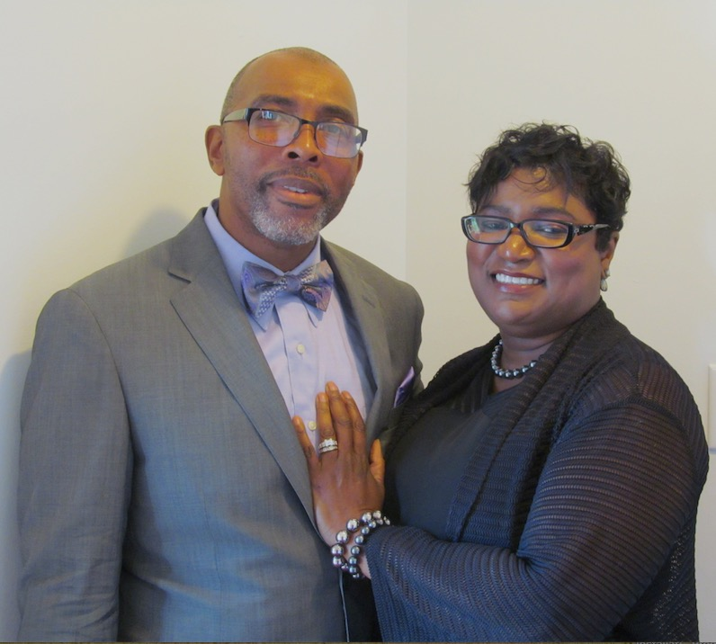
Reverend Dr. Myron Sutherlin, a native of Middlesex County, Virginia, is the fifth of seven children born to the union of Mrs. Evelyn Ruth Sutherlin and the late Deacon Robert H. Sutherlin. He received his formal education in the Middlesex County Public Schools. Upon graduation, he attended Ferrum College in Ferrum, Virginia. He continued his education at Community Bible Institute and Virginia Union University, both in Richmond, Virginia. Reverend Sutherlin matriculated at the International College of Bible Theology and received a Bachelor’s Degree in Pastoral Studies. He received a Master of Divinity degree from the Bible College of Theology in Petersburg, Virginia. On August 15, 2015, Reverend Sutherlin received a Doctor of Ministry Degree from Next Dimension in Ontario, California.
Reverend Sutherlin committed his life to Christ in July 1983. He was licensed to preach the gospel on May 4, 1991 and was ordained August 30, 1992 at the Lebanon Baptist Church in Urbanna, Virginia under the leadership of Dr. Robert H. Sutherlin & Dr. Teresa Sutherlin.
Reverend Sutherlin was called to pastor Calvary Baptist Church in Kilmarnock, Virginia, in February 1997. He dedicatedly served that congregation for 12 years, continually striving for the advancement of God’s people. During his pastorate, he initiated several growth ministries, workshops and seminars. A few of the growth ministries developed and implemented under the leadership of Reverend Sutherlin were: adult and youth Bible Study and Prayer Service, noon-day Bible Study, marriage seminars, music and finance workshops, women’s ministry, children’s church, a tutorial program, youth revival, youth workshops, the Helping Hands Committee that assisted bereaved families, new converts class discipleship and stewardship workshops, and the children and youth ministry, Step and Praise Team. He ordained two deacons, consecrated three deaconesses, licensed and ordained two ministers, and added two trustees.
Additionally at Calvary, Reverend Sutherlin’s leadership resulted in an increase in church finances and membership, the purchase of a bus and church renovations that include the addition of handicapped restrooms, a nurse’s station, a remodeled kitchen, a new digital piano, an upgraded sound system, and new lighting in the church sanctuary. He helped to continue a radio ministry (WKWI 107.1) and a tape ministry.
Reverend Sutherlin was extended the call to serve as the ninth pastor of Pleasant Grove Baptist Church in Mechanicsville, Virginia, in February 2009 through February 2011.
Reverend Sutherlin was called to Shiloh Baptist Church in James City County, Williamsburg, Virginia, as Pastor-Elect on July 17, 2016. He was installed as Pastor on June 4, 2017.
Under his leadership, several workshops were held, Praise Dance, Music/Choir, Deacon & Deaconess 6-week Training, Leadership Role Training, Trustee Leadership w/Booklet and Financial Workshop. He ordained two Deacons to the diakonos, consecrated three Deaconesses, added five Trustees, and licensed one Minister to preach the gospel.
There have been many upgrades to the church, new carpet, new upholstered pews and pulpit chairs, new audio/video sound equipment and a new sanctuary replacement window. The first Praise and Worship Team was organized in Oct 2017. Several ministries were organized to include: The Upper Room In-Touch Ministry- May 18, 2020, Outreach Through Technology Ministry, Financial Checks and Balances Committee, Safety Team & For future development, 8.6 acres of land was purchased in November 2020, and a Land Pay-Off Ministry was formed.
On March 16, 2020, COVID-19 caused Shiloh to cancel all in house church services, however the church was able to continue to move forward financially, with the assistant of the Trustees Ministry by collecting tithes, offering and introducing online Givelify, which allow members to continue to pay tithes & offering.
Reverend Sutherlin is married to 1st Lady Gillian Sutherlin. To this union, they were blessed with two daughters, Monica and Tiffanie. Reverend Sutherlin, 1st Lady, and their two daughters are a very affectionate family as well as being extremely favorable of one another. They firmly believe without hesitation that “a family that prays together stays together.”
Reverend Sutherlin continues to seek to challenge, liberate, and empower men, women and youth through the Gospel of Jesus Christ. He is guided by the scripture: “For I am not ashamed of the gospel of Christ; for it is the power of God unto salvation to everyone that believeth; to the Jew first and also to the Greek.” (Romans 1:16)

